# **Boxify: Sales Analysis and Inventory Insights**

"Boxify: Sales Analysis and Inventory Insights" sounds like a project focused on leveraging data to improve sales and inventory management.

Here’s a breakdown of what such a project might in detail:

* **Objective:**
  + Analyse the provided sales dataset to understand sales trends, stock levels, and product performance.
  + Identify popular products, low-stock items, and sales patterns over time.
* Generate actionable recommendations for improving inventory management efficiency.
* **Key Components:**

1. Sales Analysis:

* Data Collection : Obtain the sales dataset from the provided source: [Sales Analysis Dataset](https://kh3-ls-storage.s3.us-east-1.amazonaws.com/Data%20Analyst%20Project/Boxify%20Dataset%20-%20Data%20Analyst%20Bootcamp.csv).
* Data Integration: Combine data from different sources to create a unified view.
* Performance Metrics: Track key metrics such as total sales, sales by product category, sales trends over time, and customer purchase behavior.
* Reports and Dashboards: Create visual reports and dashboards to provide insights into sales performance, highlight trends, and identify opportunities or issues.

1. Inventory Insights:

* Stock Levels: Monitor current stock levels, track inventory turnover rates, and identify stockout or overstock situations.
* Demand Forecasting: Use historical sales data to predict future demand and optimize inventory levels accordingly.
* Supplier Performance: Analyze supplier reliability and lead times to improve procurement strategies.
* **Implementation Steps:**

1. Define Requirements:

* Identify the specific needs of the business regarding sales and inventory management.
* Determine key metrics and data sources.

1. Data Gathering and Preparation:

* Collect and clean sales and inventory data.
* Identify top-selling products and categories.

1. Develop Analytical Models:

* Create models for sales forecasting and inventory optimization.
* Implement algorithms for trend analysis and demand prediction.

1. Build Reports and Dashboards:

* Design and develop user-friendly interfaces for reporting and data visualization.
* Highlight insights through well-designed graphs and charts.

1. Document and Reporting:

* Summarize the findings, inventory-driven insights, and recommendations from the analysis.
* Explain how the inventory-focused insights can benefit businesses in enhancing inventory management.
* **Benefits:**
* Improved Decision-Making: Data-driven insights help make informed decisions about inventory and sales strategies.
* Increased Efficiency: Automated alerts and reports save time and reduce manual effort.
* Enhanced Profitability: Better inventory management reduces holding costs and minimizes stockouts or overstock situations.
* Recommendations should be actionable and focused on improving inventory management efficiency.

Overall, "Boxify: Sales Analysis and Inventory Insights" aims to provide a comprehensive solution for understanding and improving sales performance and inventory management through advanced data analytics and insights.

**CODE & OUTPUT:**

**Visualizing Annual Sales data distribution with a Bar Chart**

import matplotlib.pyplot as plt  
fig, ax = plt.subplots(figsize=(20,6))  
(pd.pivot_table(df,values='SoldCount', index='ReleaseYear', aggfunc='sum')).plot.bar(title = "Freq dist of Soldcount on year basis",ax = ax)

<Axes: title={'center': 'Freq dist of Soldcount on year basis'}, xlabel='ReleaseYear'>

**Freq Dist of Marketing Type**

df['MarketingType'].value_counts().plot.bar(title="Freq dist of Marketing Type")

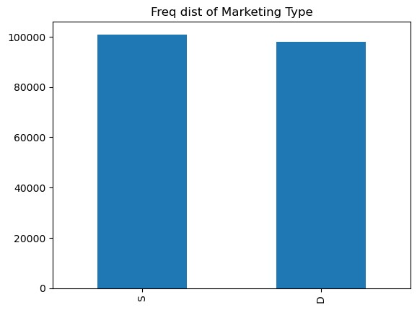

**Heat Map of Correlation Matrix for Numerical Variables**

import seaborn as sns  
numeric_df = df.select_dtypes(include=['float64', 'int64'])  
f, ax = plt.subplots(figsize=(10, 8))  
corr = numeric_df.corr()  
sns.heatmap(corr,  
            xticklabels=corr.columns.values,  
            yticklabels=corr.columns.values)  
plt.show()

